1. **Functional Description**

**Block Diagram:**

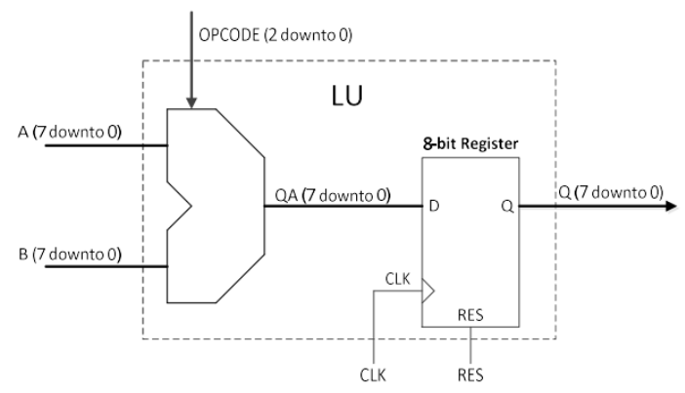

**OPCODE Selection LU**

Logic Unit (LU) designed to perform bit-wise operations on two 8-bit operands (A and B) using the OPCODE input. OPCODE input will define which bit-wise operations should be performed. Table below shows different logic function on selection of opcode.

|  |  |
| --- | --- |
| **OPCODE** | **Logic Function** |
| 000 | Q = not(A) OR B |
| 001 | Q = not(A XOR B) |
| 010 | Q = not(B) |
| 011 | Q = ( B AND “001 1001 I ”) |
| 100 | Q = A |
| 101 | Q = not(A) XNOR B |
| 110 | Q = not(A AND B) |
| 111 | Q = not(A) |

